A Complete Guide to Making Meals for Caring for Friends

Contents
- Making Meals: pg 1-3
  - Preparing Meals: pg 1-2
  - Provided Materials: pg 3
- Packaging Meals: pg 4-5
- Labeling: pg 5-6
  - Meals: pg 5
  - Soups: pg 6
- Delivering and Drop-Off: pg 6
- Tips for Meal-making: pg 7

Making Meals
Preparing Meals
Making meals is the best way to help St. Andrew’s provide for Caring for FriendsTM. You might think that the process is difficult, when it is very simple. Making meals is as easy as making meals for yourself or your family.
Simple Steps
There are steps to making meals.
- Prepare & Sanitize
Wash your hands and make sure the area in which you are working in is clean and clear. Avoid touching your face and wash your hands in between preparing food and doing anything else.
- Gather Ingredients and Materials
Gather your ingredients and materials, making sure all are clean. It is a good idea to make sure you have enough to make several meals and not just a few, as well as have extra ingredients on hand in case of an unexpected shortage. You will also need to make sure you have the proper meals tins and tin foil to package the meals after making them. These can be found in the sewing house (the small building across from St. Andrew’s church building in Yardley.
- Make the Meals
Prepare the meals. Meals can be whatever you wish, as long as they contain at least 4oz of protein per serving and a starch. When making some meals, it is important to remember that they will be cooked in an oven later, so undercooking some items are key to the recipients of these meals to enjoy them.
- Package Meals
Meals are packaged in tin trays that are provided by CFFTM and can be found inside St. Andrew’s sewing house. When putting meals in these tins, there are a few ways to do so, as displayed below.
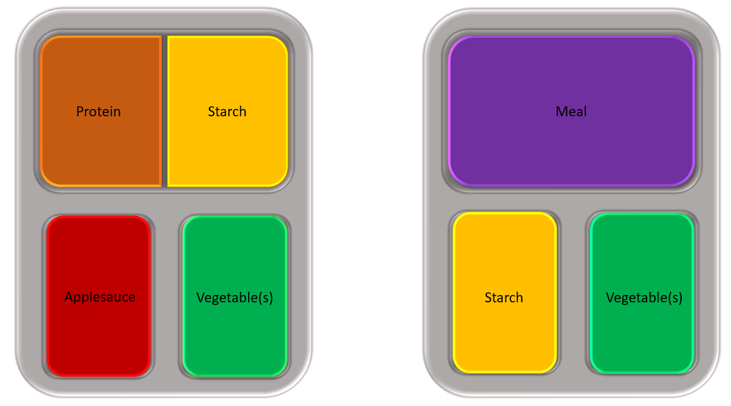
Meals are recommended to have at least 4oz of protein, and must contain sides of a vegetable(s) and either a starch or applesauce. Canned peaches have also been found as a doable substitute for applesauce. The compartments cannot be overfilled, and it is recommended that the sides are done in ¼ cup servings.
Once the meals are placed in the trays, cover the top with tinfoil and tuck the tinfoil underneath the overhanging sides of the tray. This will preserve the meals and keep them from spilling out of the sides. Ensure that the tinfoil doesn’t rip when you do this.
- Clean Up
When you finish packing the meals, place them in a freezer until you go to fully bag and deliver them. Make sure to wash your hands after preparing and packaging the food.

Provided Materials
Caring for FriendsTM provides St. Andrew’s in Yardley with materials to make and package meals.
Materials to package meals, like
- Tin foil
- Tin trays
- Soup containers
- Twisty-ties
- Bags
- Soup and meal labels
Can be found in the sewing house, located in the blue circled area.
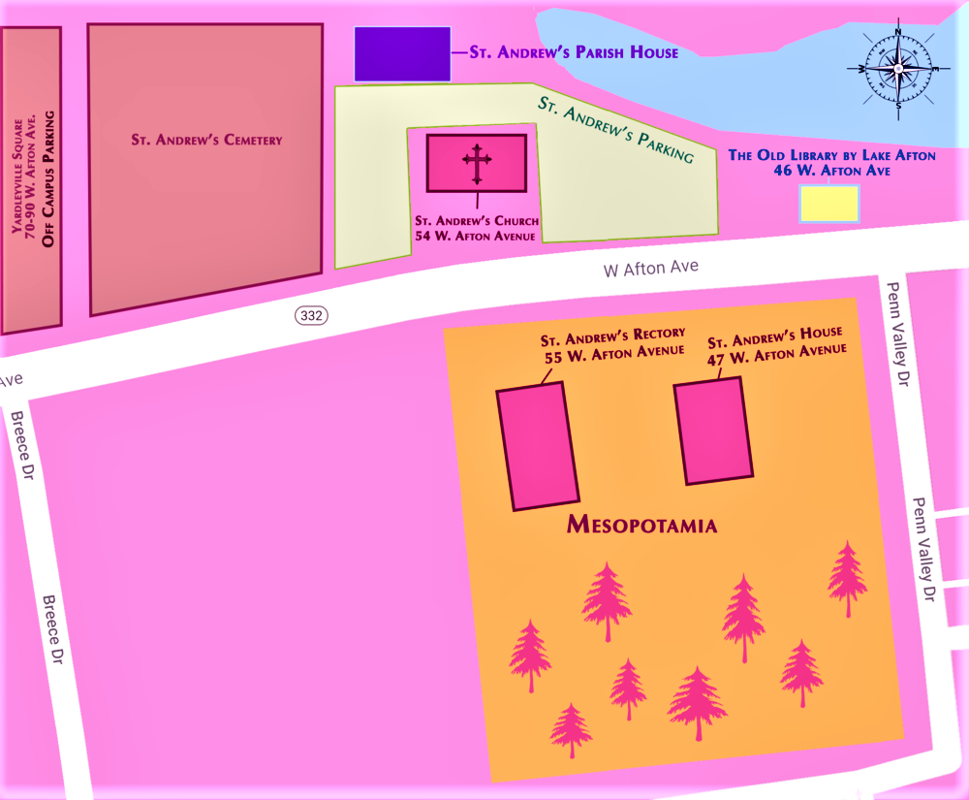

Protein, vegetables and other meal supplies can be found in the Parish house, or can be delivered every drop-off Monday.
Packing Meals
Meals must be bagged and labeled, to do this you will need:
- Meal bags
- Meal labels
- Twisty-ties
Meals can also include other things to provide a complete meal; traditionally this included:
- Bread
- Butter pat
- Snack (often one or two cookies)
- Two candies or mints
- Tea bag
However, with the current situation the world is in we have been unable to obtain all of these supplies except tea and sometimes candy or snacks. While we would like for people to include these in the meal bags, only the tea is really necessary.
Simple Steps
These are the steps to package meals.
- Prepare
Make sure your area is clear and clean. Wash your hands and grab all of the supplies to begin bagging the meals.
- Bagging
Bag the meals in this order: meal, other available items, label. The label must be visible, placed neatly and flat on top of everything else that was placed in the bag.
- Tying
Take the bag and twisty-tie the end closed. Place the fully-packaged meal in a freezer or deliver to the church right away.
It is important to make sure you have everything you need before you begin to bag the meals.
Labeling
Labeling Meals
Labeling is imperative as it lets the people who receive these meals know if they are unable to eat them due to any dietary restrictions.
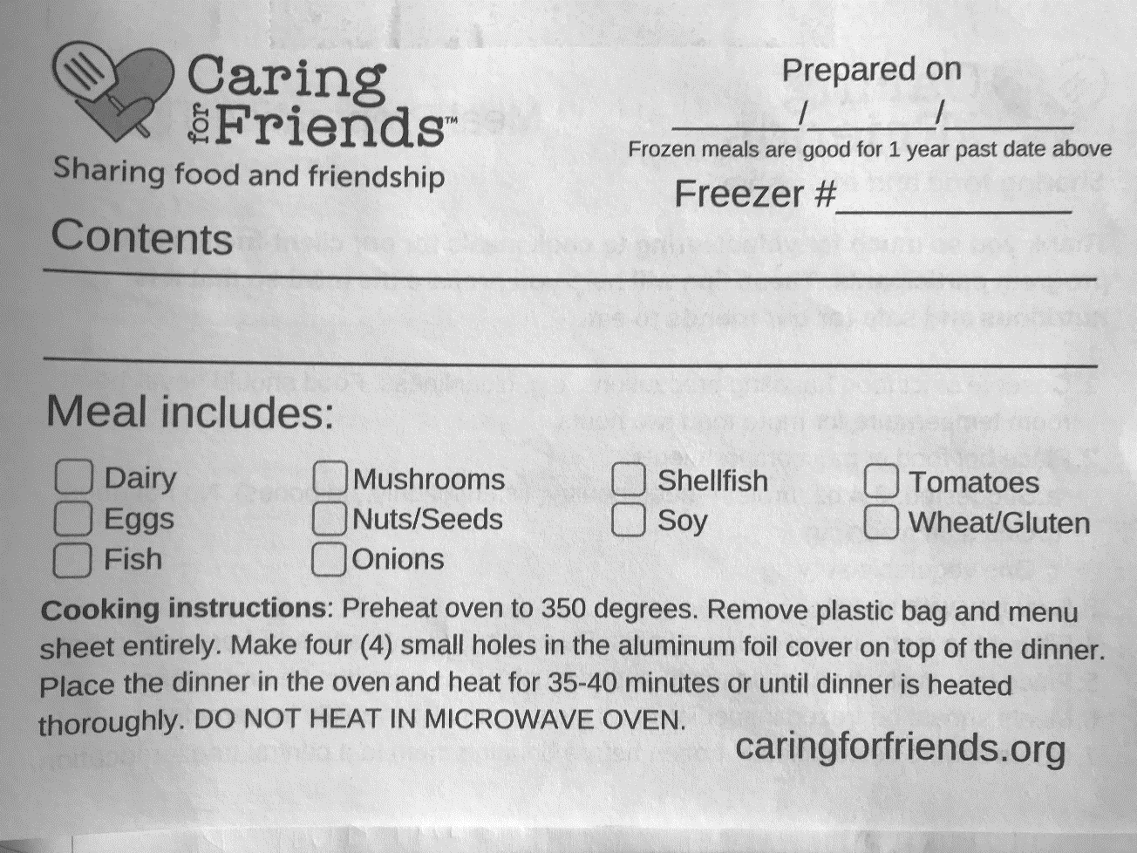
(1)

(2)

(3)

Labels can be found in the sewing room.
Follow the numbered areas above.
- Put the date when you prepared the meal here. This is its expiration date a year from when you made it.
- Include all of the food that is inside the meal tin here. This includes the main course and sides.
- Mark off any boxes that have ingredients that are included in the meal. Leave all the rest blank.
This label will go on top of the meals once they are bagged.
Labeling Soups
Soups are much easier to label.
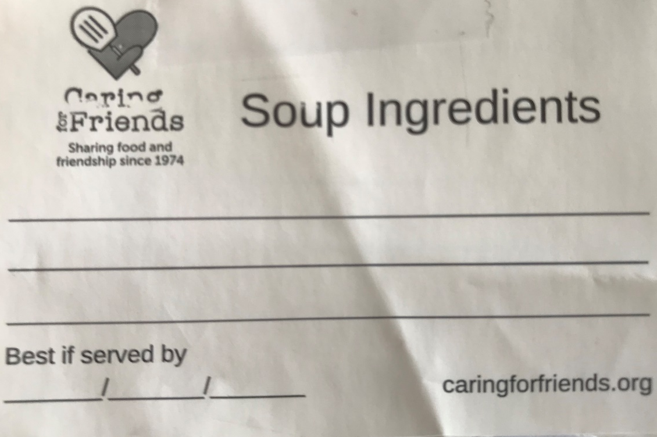

(1)

(2)

Follow the numbered areas above.
- Put the type of soup here and any ingredients that might cause an allergic reaction, as well as any meat products.
- Write down the date that you made the soup here, but place add on a year. This will be its “expiration date.”
Labels are then stuck to soup containers.
Delivery and Drop-off
Meal drop-off dates can be found on the Food Justice calendar on the St. Andrews website. They are usually biweekly (every two weeks.) During those days meals can be dropped off at the Parish house between 8am and 9:30am.
Meals can also be delivered to the Parish house everyday before 6pm, though the code to the Parish house is required for that.

Tips for Meal-Making
Here are a few tips/tricks we have collected over the months to make meal making easier.
- Get the family involved
Things are easier when you aren’t doing them alone. If you don’t live alone, involve your family in making and assembling meals. It makes things go easier and some kids’ schools count CFF as community service.
- Create an assembly line
Meals are easier to put into the tins when its done in an assembly line, or even if you line up all the trays and put in things one at a time and then wrap.
- Make in Batches
Make meals in large batches/continuously and adjusting your recipes for these batches makes it so you’re not making several separate meals. Cooking goes much quicker.
- Undercook Starch
Undercooking starchy items allows for them to be perfectly cooked after the recipients heat them up at home. This works well for pasta, mashed potatoes, etc.
- Add Sauce
Adding sauces or gravy to meals not only adds a lot of flavor; it also prevents freezer burn.
- Stretching Meals
Since we are trying to feed several hundred people each week, stretching meals is necessary. Adding filler to some meals, like corn or peas, or placing your starch like the first image on pg 2 is done allows for proteins to stretch out to more meals without compromising the amount or quality.
- Be Mindful of Quality
Using leaner cuts of meat makes it easier for seniors to consume these meals, so try to use them when given the option.

